Ms_Thesis Progress

Please create 5-6 slides for your thesis so that the whole objectives are clear.. It should include-
1. Research problem
2. Importance of the problem
3. Research Gap
4. Research Objectives
5. Tentative timeline with deliverables.
You can divide the research objectives into 2 parts (covering the 1 year) if you want.

Objectives:
Objective 1: To systematically study the impact of low-light image enhancement methods on image quality, object-detection performance, and generalization across raw and enhanced image domains under diverse low-light conditions.
Objective 2:

Experimental design
Show the pipeline:

Dataset
ExDark
7,363 images
12 classes
Train 5,154 | Val 1,472 | Test 737

Detectors
YOLOv8n YOLOv10n | RT-DETR | Faster R-CNN | Deformable DETR

Enhancement methods
Zero-DCE++ | SCI | Retinexformer | SNR-Aware | PairLIE | KinD++ | LIME

SUMMARY 08-08-2026
DOES Low-light enhancement improve Object detection? IF so Why?

1) pretrained object detector model trained on which dataset
2) Experimental protocols in Deep Learning
3) enhancement methods, captioning methods
4) metrics
5)

14-08-2026
OD guided LLIE ob awareness imp
Effect of llie on object detection whether llie improves or not reason:

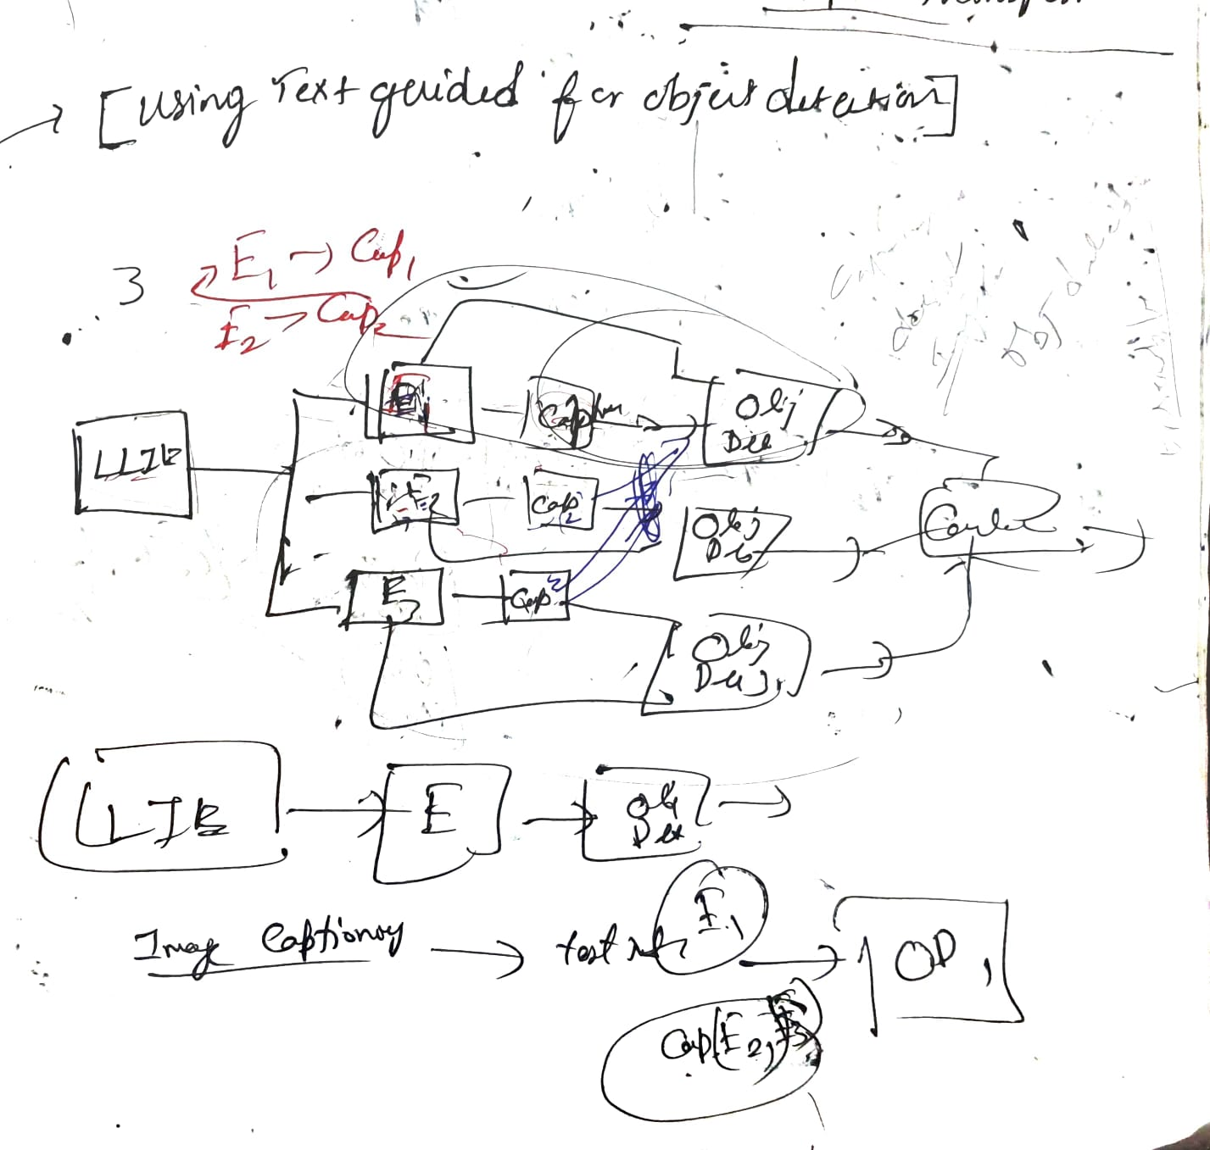

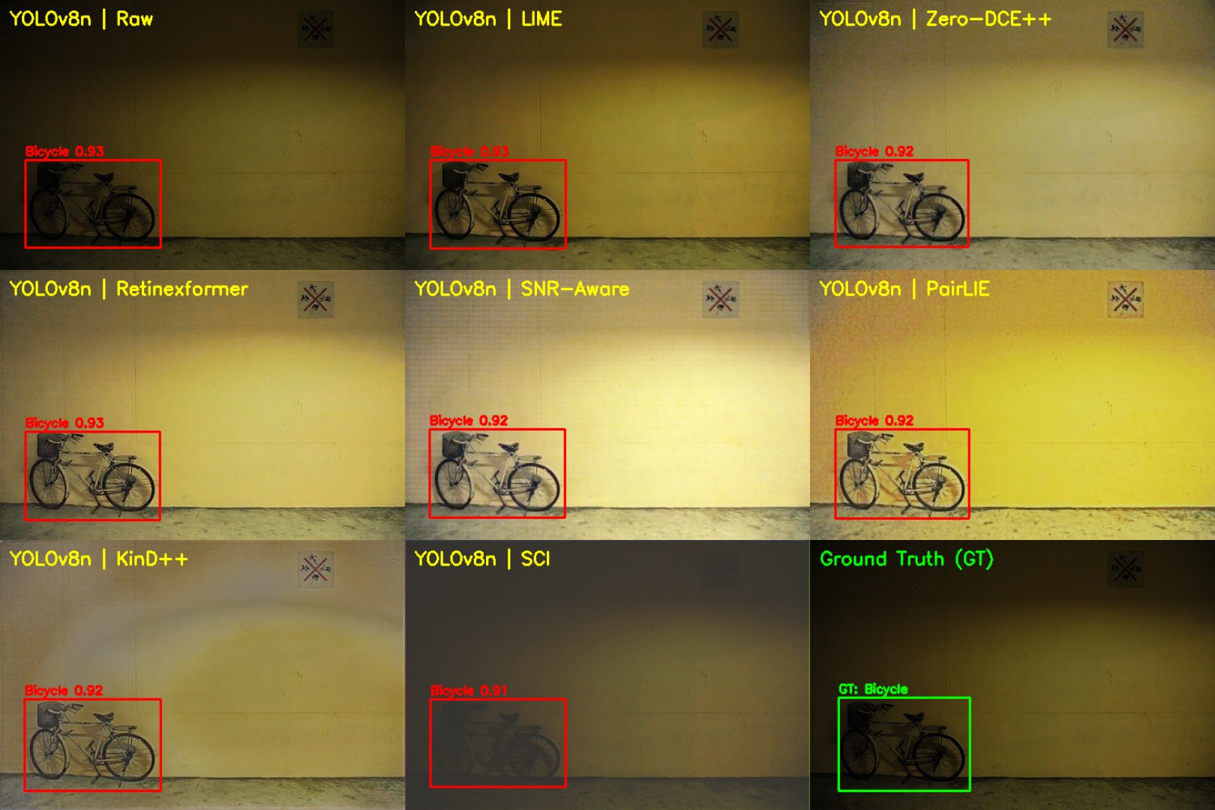
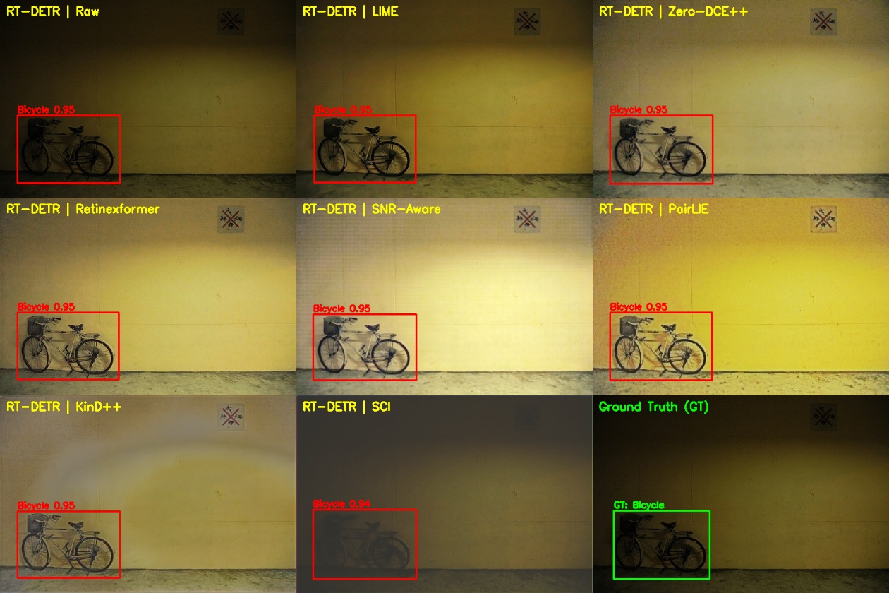
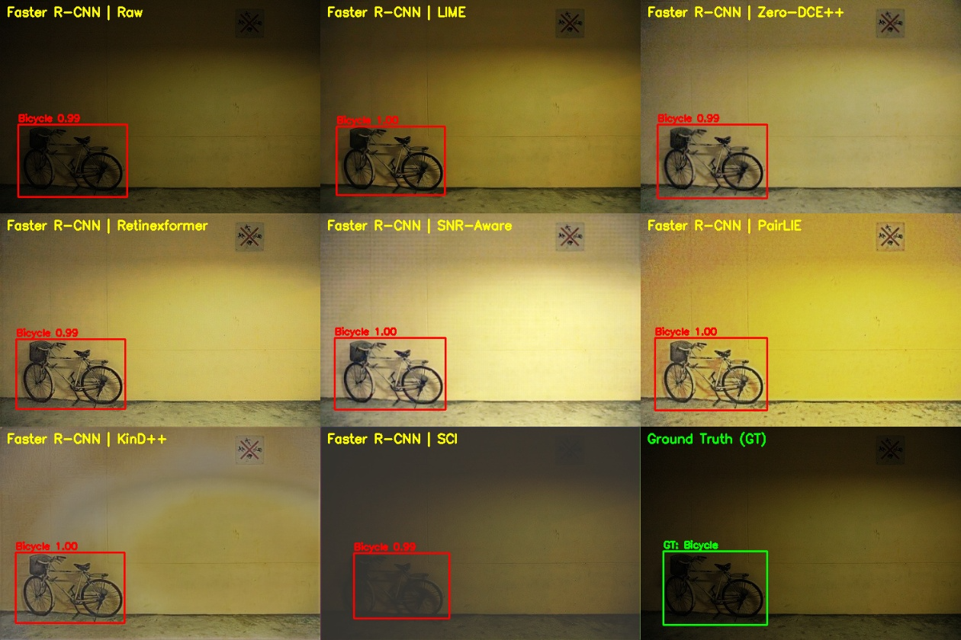
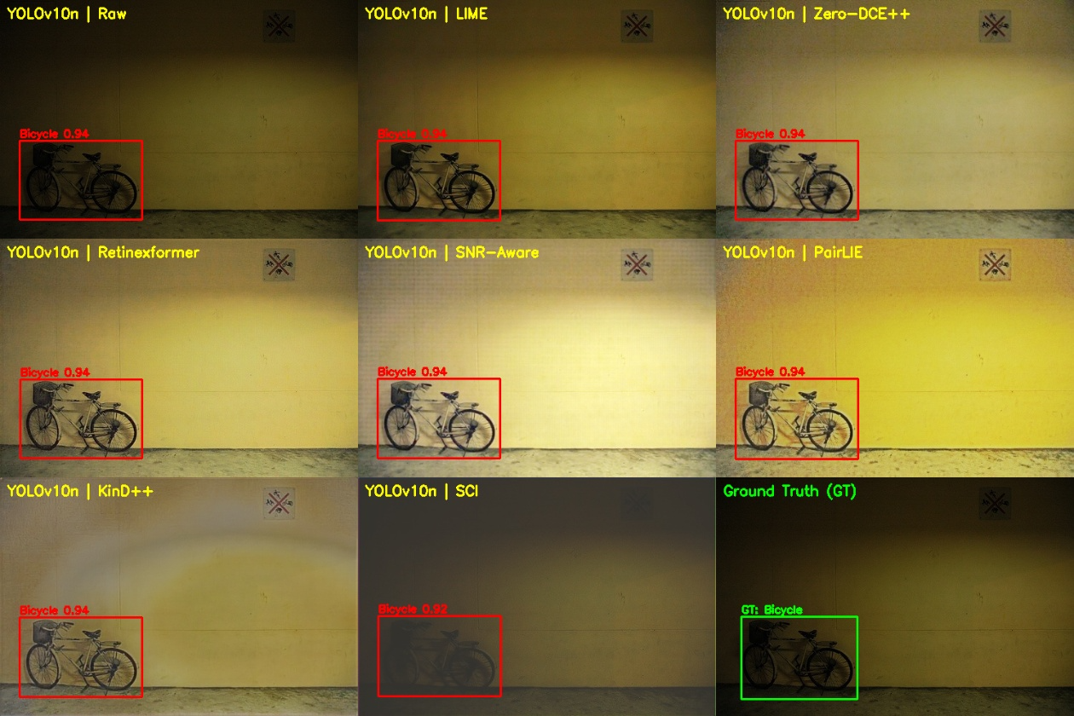

10% Random Test Sample (N=74 Images) with all 5 object detectors

 | YOLOv8n | YOLOv10n | RT-DETR | Faster R-CNN | Deformable DETR
Raw | 0.7081 | 0.6992 | 0.7287 | 0.7766 | 0.6391
LIME | 0.7125 | 0.7010 | 0.7600 | 0.7893 | 0.6255
Zero-DCE++ | 0.6779 | 0.6755 | 0.7232 | 0.7798 | 0.6254
Retinexformer | 0.6420 | 0.6641 | 0.7160 | 0.7478 | 0.5763
SNR-Aware | 0.6522 | 0.6583 | 0.6721 | 0.7582 | 0.5521
PairLIE | 0.5854 | 0.6147 | 0.6801 | 0.7234 | 0.5061
KinD++ | 0.5876 | 0.5754 | 0.6867 | 0.7210 | 0.5378
SCI | 0.6011 | 0.5722 | 0.6409 | 0.5849 | 0.4836

23-08-2026

Exdark dataset
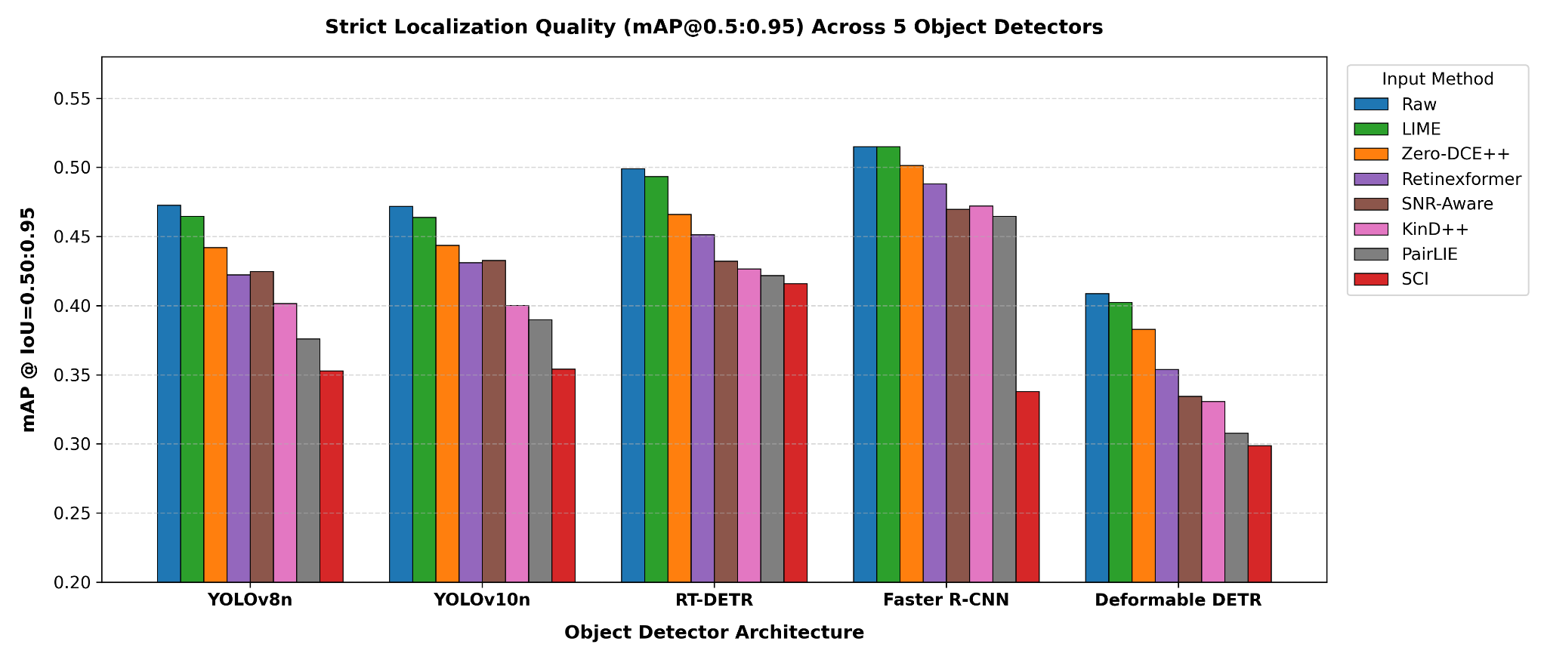

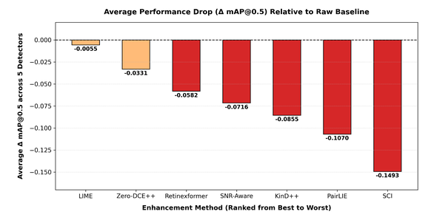

24-08-2026
Exdark DATASET
Extending to LLVIP-visible.
Literature survey
current study is:
ExDark → Raw low-light images → trained five object detectors → test Raw and enhanced images using the same Raw-trained detectors → compare detection performance.
Scale-Dependent Effect of LLIE on Detection Performance

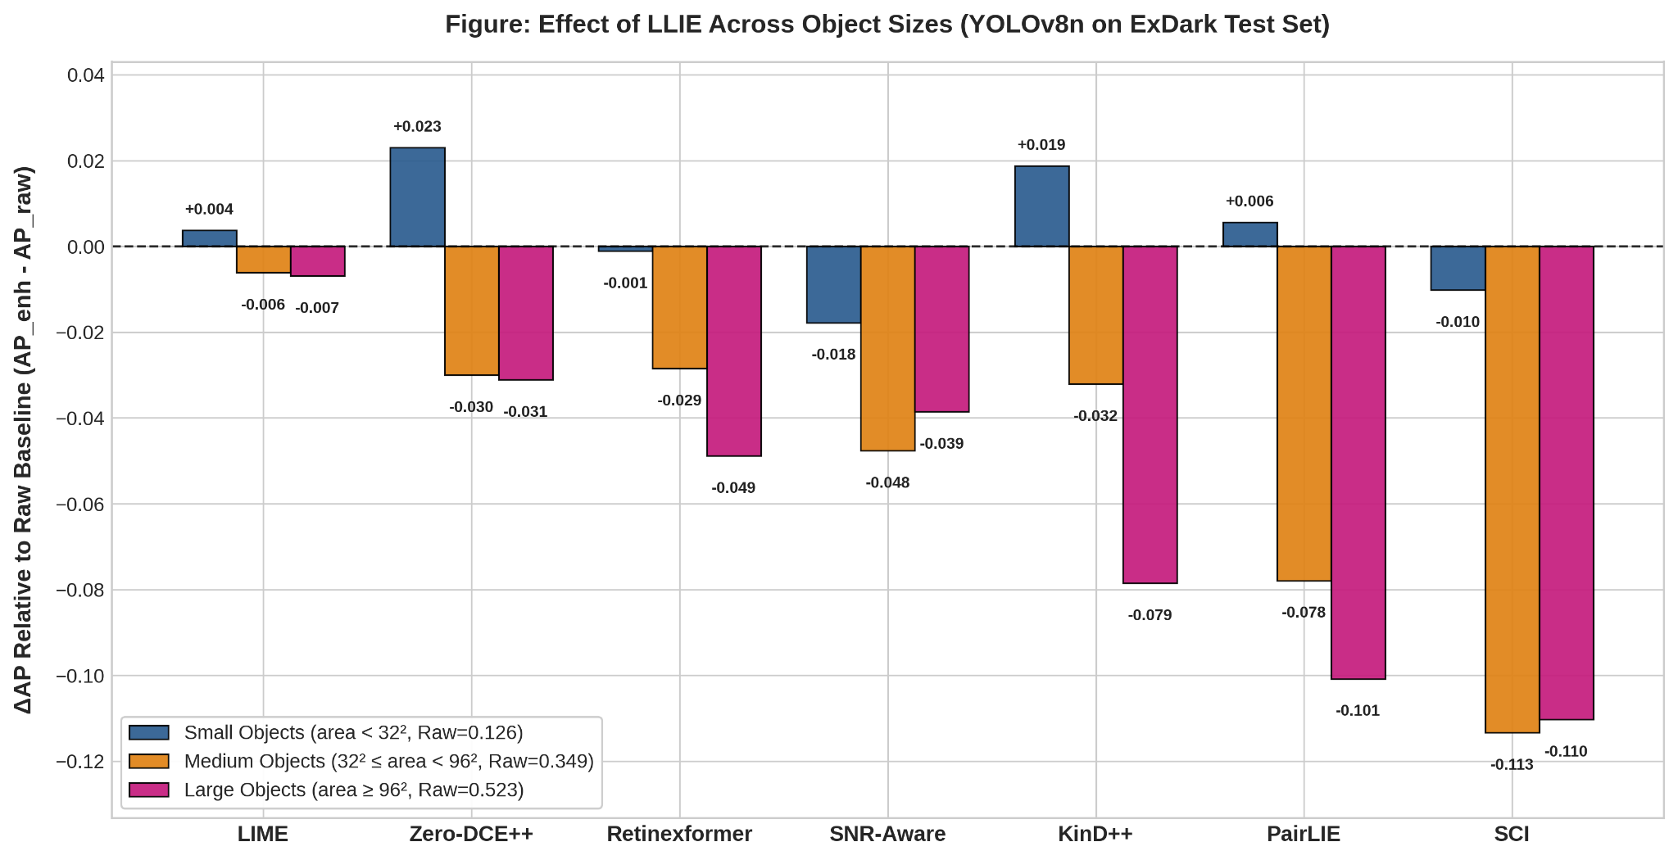

LIME: almost zero change at all sizes
Zero-DCE++: small improves, medium/large decrease
SCI: very large decreases for medium/large
PairLIE: large decrease, especially large objects
KinD++: small improves, large decreases
Retinexformer: medium/large decrease
SNR-Aware: medium/large decrease

Does the amount of darkness in the original image affect how much an enhancement method changes object-detection performance?

27-08-2026
https://drive.google.com/drive/folders/1BnOjwEkSA6Wi52DPvz7KAKYr5Kdc-akE?usp=drive_link
Next step: Image Registration

28 - 08 - 2026 to september 7 2026 work update

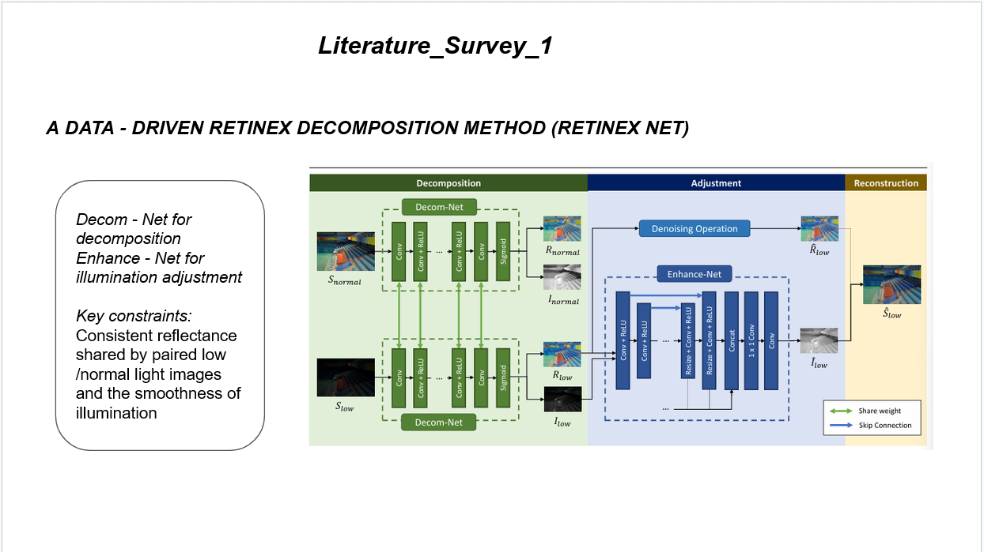
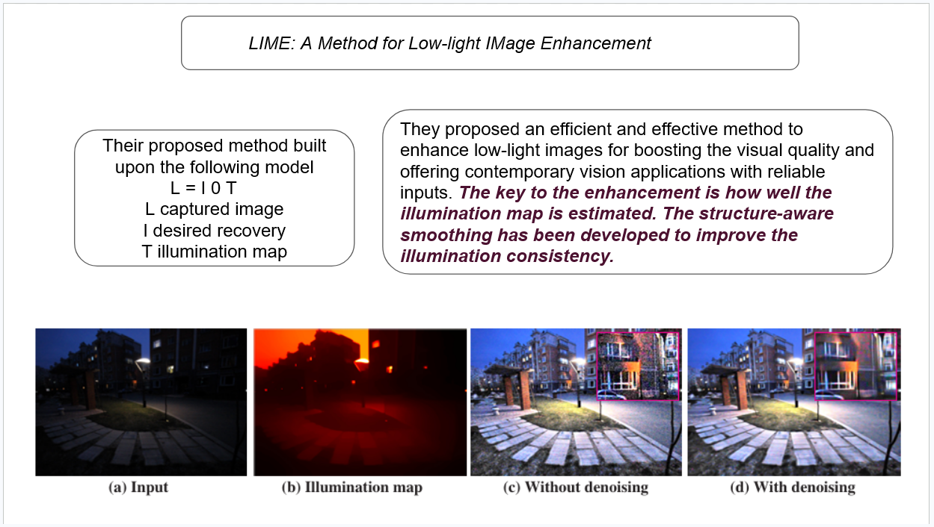

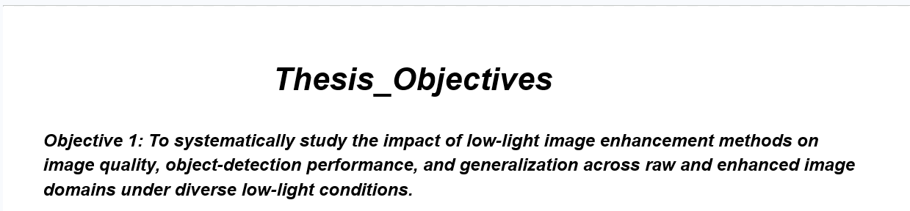

Protocol | Train | Test | Why needed
P1 | Raw | Raw | Normal baseline DONE
P2 | Raw | Enhanced | Tests whether enhancement at inference causes domain shift DONE
P3 | Enhanced | Enhanced | Tests whether detector can adapt to enhanced domain DONE

LITERATURE_SURVEY_1_List: Research gaps
LIME | Done | Survey paper, empirical study
ZeroDCE++ | Need to update properly this table | Retinexnet
RetinexFormer
SNR-AWARE
KinD++
Pairlie
SCI

P2 enhancer × detector benchmark mAP@0.5
Enhancer | YOLOv8 | YOLOv10 | RT-DETR | Faster R-CNN | Deformable DETR
Raw | 0.7332 | 0.7309 | 0.7626 | 0.8176 | 0.6697
LIME | 0.7233 | 0.7240 | 0.7593 | 0.8219 | 0.6578
Zero-DCE++ | 0.6925 | 0.6996 | 0.7205 | 0.8036 | 0.6321
SCI | 0.5892 | 0.5952 | 0.6615 | 0.6031 | 0.5184
Retinexformer | 0.6675 | 0.6809 | 0.7009 | 0.7838 | 0.5904
SNR-Aware | 0.6707 | 0.6776 | 0.6823 | 0.7642 | 0.5613
PairLIE | 0.6008 | 0.6258 | 0.6696 | 0.7558 | 0.5271
KinD++ | 0.6394 | 0.6483 | 0.6729 | 0.7641 | 0.5620

Experiments and protocols
Protocol 1 P1: Raw → Raw
Detector | mAP@0.5 | mAP@0.5:0.95 | Precision | Recall | F1
YOLOv8n | 0.7332 | 0.4727 | 0.8119 | 0.6370 | 0.7139
YOLOv10n | 0.7309 | 0.4719 | 0.7984 | 0.6489 | 0.7159
RT-DETR | 0.7626 | 0.4990 | 0.8299 | 0.7222 | 0.7723
Faster R-CNN | 0.8176 | 0.5150 | 0.8419 | 0.7287 | 0.7812
Deformable DETR | 0.6697 | 0.4087 | 0.8204 | 0.6141 | 0.7024

Protocol 2 P2: Raw → Enhanced YOLOv8n

Input | mAP@0.5 | Δ vs Raw
Raw | 0.7332 | —
LIME | 0.7233 | -0.0099
Zero-DCE++ | 0.6925 | -0.0407
SNR-Aware | 0.6707 | -0.0625
Retinexformer | 0.6675 | -0.0657
KinD++ | 0.6394 | -0.0938
PairLIE | 0.6008 | -0.1324
SCI | 0.5892 | -0.1440

P2 uses the detector trained on raw ExDark images and evaluates the same detector on enhancement outputs; therefore, the observed change measures the effect of the input-domain shift induced by enhancement.

Protocol 3 P3: Enhanced → Enhanced

Method | P1 Raw | P2 | P3 | P2→P3
LIME | 0.7332 | 0.7233 | 0.7315 | +0.0082
Zero-DCE++ | 0.7332 | 0.6925 | 0.7292 | +0.0367
SCI | 0.7332 | 0.5892 | 0.6784 | +0.0892
Retinexformer | 0.7332 | 0.6675 | 0.7209 | +0.0534
SNR-Aware | 0.7332 | 0.6707 | 0.7071 | +0.0364

P3 adapts YOLOv8n to each enhancement-specific image domain and evaluates on the corresponding enhanced test set.

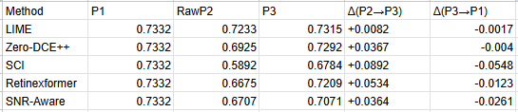

A systematic review of deep learning methods for low light image enhancement and object detection (2026)

Effect of LLIE on object detection
Whether LLIE improves object detection or not?
Reason:

Research_Problem

Prompt :

09-09-2026

EXDARK DATASET

Stage 3- Add the missing protocol that explains our current drop

Protocol | Train | Test | Why needed
P1 | Raw | Raw | Normal baseline DONE
P2 | Raw | Enhanced | Tests whether enhancement at inference causes domain shift DONE
P3 | Enhanced | Enhanced | Tests whether detector can adapt to enhanced domain DONE
P4 | Raw + Enhanced mixed | Raw + Enhanced | Tests robust training
P5 | Detection-aware enhancement + detector | Enhanced/adaptive | our proposed solution
Llvip Dataset

Protocol | Train | Test | Why needed
P1 | Raw | Raw | Normal baseline
P2 | Raw | Enhanced | Tests whether enhancement at inference causes domain shift
P3 | Enhanced | Enhanced | Tests whether detector can adapt to enhanced domain
P4 | Raw + Enhanced mixed | Raw + Enhanced | Tests robust training
P5 | Detection-aware enhancement + detector | Enhanced/adaptive | our proposed solution
O1 can investigate:

Dataset | Input | Detector | mAP@0.5 | mAP@0.5:0.95 | Precision | Recall | F1
ExDark | Raw | YOLOv8n | 0.7332 | 0.4727 | 0.8119 | 0.6370 | 0.7139
ExDark | Raw | YOLOv10n | 0.7309 | 0.4719 | 0.7984 | 0.6489 | 0.7159
ExDark | Raw | RT-DETR | 0.7626 | 0.4990 | 0.8299 | 0.7222 | 0.7723
ExDark | Raw | Faster R-CNN | 0.8176 | 0.5150 | 0.8419 | 0.7287 | 0.7812
ExDark | Raw | Deformable DETR | 0.6697 | 0.4087 | 0.8204 | 0.6141 | 0.7024
ExDark | Zero-DCE++ | YOLOv8n | 0.6925 | 0.4420 | 0.7787 | 0.6067 | 0.6820
ExDark | Zero-DCE++ | YOLOv10n | 0.6996 | 0.4436 | 0.7540 | 0.6327 | 0.6880
ExDark | Zero-DCE++ | RT-DETR | 0.7205 | 0.4660 | 0.8227 | 0.6736 | 0.7407
ExDark | Zero-DCE++ | Faster R-CNN | 0.8036 | 0.5015 | 0.8183 | 0.7333 | 0.7735
ExDark | Zero-DCE++ | Deformable DETR | 0.6321 | 0.3830 | 0.7964 | 0.5804 | 0.6714
ExDark | SCI | YOLOv8n | 0.5892 | 0.3527 | 0.7046 | 0.5185 | 0.5974
ExDark | SCI | YOLOv10n | 0.5952 | 0.3541 | 0.7343 | 0.5226 | 0.6106
ExDark | SCI | RT-DETR | 0.6615 | 0.4160 | 0.8271 | 0.5989 | 0.6947
ExDark | SCI | Faster R-CNN | 0.6031 | 0.3380 | 0.7490 | 0.5397 | 0.6273
ExDark | SCI | Deformable DETR | 0.5184 | 0.2986 | 0.7316 | 0.4862 | 0.5842
ExDark | Retinexformer | YOLOv8n | 0.6675 | 0.4225 | 0.7506 | 0.5972 | 0.6652
ExDark | Retinexformer | YOLOv10n | 0.6809 | 0.4312 | 0.7453 | 0.6191 | 0.6764
ExDark | Retinexformer | RT-DETR | 0.7009 | 0.4514 | 0.8212 | 0.6452 | 0.7226
ExDark | Retinexformer | Faster R-CNN | 0.7838 | 0.4881 | 0.8366 | 0.6901 | 0.7563
ExDark | Retinexformer | Deformable DETR | 0.5904 | 0.3540 | 0.7778 | 0.5495 | 0.6440
ExDark | SNR-Aware | YOLOv8n | 0.6707 | 0.4247 | 0.7562 | 0.6103 | 0.6755
ExDark | SNR-Aware | YOLOv10n | 0.6776 | 0.4326 | 0.7177 | 0.6293 | 0.6706
ExDark | SNR-Aware | RT-DETR | 0.6823 | 0.4321 | 0.8021 | 0.6499 | 0.7180
ExDark | SNR-Aware | Faster R-CNN | 0.7642 | 0.4698 | 0.8090 | 0.6876 | 0.7434
ExDark | SNR-Aware | Deformable DETR | 0.5613 | 0.3345 | 0.7434 | 0.5467 | 0.6300
ExDark | PairLIE | YOLOv8n | 0.6008 | 0.3760 | 0.6897 | 0.5567 | 0.6161
ExDark | PairLIE | YOLOv10n | 0.6258 | 0.3898 | 0.7324 | 0.5633 | 0.6368
ExDark | PairLIE | RT-DETR | 0.6696 | 0.4219 | 0.8165 | 0.6133 | 0.7005
ExDark | PairLIE | Faster R-CNN | 0.7558 | 0.4648 | 0.7867 | 0.6897 | 0.7350
ExDark | PairLIE | Deformable DETR | 0.5271 | 0.3078 | 0.7494 | 0.4990 | 0.5991
ExDark | KinD++ | YOLOv8n | 0.6394 | 0.4015 | 0.7201 | 0.5777 | 0.6411
ExDark | KinD++ | YOLOv10n | 0.6483 | 0.4002 | 0.7272 | 0.5885 | 0.6505
ExDark | KinD++ | RT-DETR | 0.6729 | 0.4265 | 0.8214 | 0.6221 | 0.7080
ExDark | KinD++ | Faster R-CNN | 0.7641 | 0.4721 | 0.8107 | 0.6885 | 0.7446
ExDark | KinD++ | Deformable DETR | 0.5620 | 0.3306 | 0.7496 | 0.5290 | 0.6202
ExDark | LIME | YOLOv8n | 0.7233 | 0.4646 | 0.7882 | 0.6408 | 0.7069
ExDark | LIME | YOLOv10n | 0.7240 | 0.4640 | 0.8056 | 0.6397 | 0.7131
ExDark | LIME | RT-DETR | 0.7593 | 0.4935 | 0.8402 | 0.7163 | 0.7733
ExDark | LIME | Faster R-CNN | 0.8219 | 0.5150 | 0.8295 | 0.7378 | 0.7809
ExDark | LIME | Deformable DETR | 0.6578 | 0.4023 | 0.7966 | 0.6116 | 0.6919

ExDARK Table 4: Per-class ΔAP yolov8n
1 | Class | Raw AP | Zero-DCE++ ΔAP | SCI ΔAP | Retinexformer ΔAP | SNR-Aware ΔAP | PairLIE ΔAP | KinD++ ΔAP | LIME ΔAP | Ours ΔAP
2 | Bicycle | 0.8461 | 0.017 | -0.1397 | -0.0199 | -0.016 | -0.0658 | -0.0114 | -0.0041 | TBD
3 | Boat | 0.7364 | -0.0086 | -0.1213 | -0.0139 | -0.0325 | -0.0497 | -0.0249 | 0.0288 | TBD
4 | Bottle | 0.6787 | -0.0749 | -0.1682 | -0.058 | -0.0843 | -0.1672 | -0.1039 | -0.0136 | TBD
5 | Bus | 0.8781 | -0.0218 | -0.0559 | -0.0476 | -0.0045 | -0.0891 | -0.0536 | 0.006 | TBD
6 | Car | 0.7507 | -0.0368 | -0.1397 | -0.0721 | -0.0533 | -0.1427 | -0.0698 | -0.0068 | TBD
7 | Cat | 0.7691 | -0.0925 | -0.2253 | -0.145 | -0.1312 | -0.2556 | -0.204 | -0.0274 | TBD
8 | Chair | 0.6079 | -0.0351 | -0.1765 | -0.067 | -0.0754 | -0.0893 | -0.1234 | -0.0171 | TBD
9 | Cup | 0.6972 | -0.0626 | -0.1341 | -0.1329 | -0.1183 | -0.1362 | -0.1238 | -0.015 | TBD
10 | Dog | 0.7986 | -0.0844 | -0.1221 | -0.0756 | -0.0872 | -0.2023 | -0.1575 | -0.0482 | TBD
11 | Motorbike | 0.8098 | -0.0409 | -0.1588 | -0.051 | -0.0449 | -0.1629 | -0.0891 | -0.0123 | TBD
12 | People | 0.7455 | -0.0075 | -0.1528 | -0.0489 | -0.0425 | -0.0902 | -0.0632 | -0.0038 | TBD
13 | Table | 0.48 | -0.0396 | -0.134 | -0.0561 | -0.0593 | -0.1377 | -0.1002 | -0.0054 | TBD

Object-size analysis using YOLOv8n

Proposed Model :

The proposed model is a detection-preserving, physics-aware, object-aware low-light adaptation model.

DPI-Det: Detection-Preserving Illumination Inversion Network for Low-Light Object Detection
The core idea:
Instead of enhancing the whole image to look good for humans, DPI-Det learns where, how much, and in what feature direction to correct illumination so that object detectors perform better.
This is different from Zero-DCE++, SCI, Retinexformer, LIME, PairLIE, etc., because those are mainly designed for visual enhancement, while our benchmark shows that visual enhancement often hurts mAP.
1. Why this proposed model is needed
our current results show:
Input | Effect
Raw ExDark | Best detection performance
Zero-DCE++ | Detection drops
SCI | Large detection drop
Retinexformer | Detection drops
This matches recent research. A 2024 empirical study found that LLIE methods may improve human visual interpretation, but their effect on classification and object detection is inconsistent and can even be harmful. (arXiv) LIME-Eval also argues that evaluating enhancement by retrained object detectors can be biased and that LLIE evaluation for downstream vision needs more careful design. (arXiv)

2.1 Retinex physics
Low-light enhancement is usually based on Retinex theory. Land’s Retinex theory connects perceived color/lightness more strongly to surface reflectance than raw illumination intensity. (Optica Publishing Group) In computer vision, Retinex-based LLIE usually assumes that an observed image can be decomposed into reflectance and illumination. RetinexNet uses this idea by learning a decomposition network and an illumination-adjustment network on the LOL dataset. (arXiv)
The usual model is:
[
I = R \odot L + n
]
Where:
Symbol | Meaning
(I) | observed low-light image
(R) | reflectance / object structure / material appearance
(L) | illumination map
(n) | sensor noise
(\odot) | pixel-wise multiplication
Most enhancers try to estimate (L), increase brightness, and recover a visually pleasing image. But our detection results show that this can damage object features.

2.2 Low-light sensor noise
In low light, the camera receives fewer photons, so photon shot noise becomes important. Photon noise is commonly modeled as Poisson noise because it comes from the quantized nature of light measurement. (MIT CSAIL) Modern low-light raw denoising papers also use physics-based noise models to synthesize realistic low-light noise under extreme conditions. (CVF Open Access)
This matters because if an enhancer blindly amplifies dark pixels, it may amplify noise along with signal. That can explain why SCI and Retinexformer may look brighter but reduce detection accuracy.
So DPI-Det should not enhance all dark pixels equally. It should estimate:
[
S(x) = \frac{\mu(x)}{\sqrt{\alpha \mu(x) + \beta} + \epsilon}
]
Where:
Symbol | Meaning
(S(x)) | estimated signal-to-noise confidence at pixel (x)
(\mu(x)) | local brightness / signal estimate
(\alpha,\beta) | learnable or estimated Poisson-Gaussian noise parameters
(\epsilon) | numerical stability
High-SNR dark regions can be enhanced. Low-SNR noisy regions should be enhanced carefully or denoised first.
This is connected to SNR-Aware LLIE, which uses Signal-to-Noise-Ratio-aware transformers and convolutional models to dynamically enhance regions with spatially varying operations. (CVF Open Access)

3. What already exists, and where our novelty can be
Existing work | What it does | Limitation for our paper
LIME | Estimates illumination map and enhances low-light images. (ACM Digital Library) | Classical, not detection-aware
RetinexNet | Learns reflectance/illumination decomposition. (arXiv) | Visual enhancement, not object-detection optimized
Zero-DCE / Zero-DCE++ | Learns image-specific enhancement curves without paired data. (arXiv) | No object-aware detection loss
SCI | Fast self-calibrated illumination learning. (CVF Open Access) | Can be fast but may hurt mAP in our results
SNR-Aware | Uses SNR-aware transformers/convolutions. (CVF Open Access) | SNR-aware but not explicitly box/object-loss guided
PairLIE | Learns from paired low-light instances without normal-light GT. (CVF Open Access) | Enhancement-focused
Retinexformer | One-stage Retinex-based transformer with illumination-guided attention. (arXiv) | Strong LLIE baseline, but still primarily enhancement-focused
Diff-Retinex | Combines Retinex decomposition and diffusion generation. (arXiv) | Heavy, generative, not ideal as real-time detector-preserving method
Dynamic LLIE for object detection | End-to-end enhancement + detection; dynamically selects enhancement subnetworks. (wuyirui.github.io) | Closest prior work; our model must be clearly different
DAI-Net CVPR 2024 | Zero-shot day-night domain adaptation using Retinex-inspired reflectance representation. (CVF Open Access) | Domain adaptation, not our benchmark + adaptive detector-preserving enhancer
FeatEnHancer | Enhances hierarchical features for low-light detection and related tasks. (arXiv) | Feature-level only; our model can combine image-level physical inversion + detector feature preservation
AMIEOD 2026 arXiv | Multi-expert enhancement for low-light object detection with detection-guided losses. (arXiv) | Very close recent preprint; our novelty must avoid being only “multi-expert enhancement + detector”

We introduce an object-aware, SNR-constrained, Retinex-inversion module that learns a continuous illumination correction map and a feature-space detector adapter, optimized by detection preservation rather than perceptual enhancement.

4. Proposed model: DPI-Det

4.1 High-level pipeline
Low-light image I
↓
Physics-guided Retinex-SNR Encoder
↓
Object-aware Illumination Inversion Module
↓
Detection-preserving Image Output I_dpi
↓
Detector Backbone
↓
Feature Inversion Adapter
↓
Detector Neck + Head
↓
Boxes + Classes

DPI-Det has two outputs:
Output | Purpose
(I_{dpi}) | detection-preserving enhanced image
(F_{dpi}) | adapted detector feature representation
This is important. we are not only making a prettier image. we are making a detector-friendly representation.

5. Main equation
our earlier equation was:
[
Y_{GT} = Y_P \times W
]
This is too vague. Replace it with:
[
I_{dpi} = \operatorname{clip}(I_{raw} \odot W_\theta(I_{raw}, S, M_{obj}))
]
Where:
Term | Meaning
(I_{raw}) | original low-light image
(W_\theta) | learned illumination inversion map
(S) | estimated SNR confidence map
(M_{obj}) | object-aware mask/proposal attention
(I_{dpi}) | detection-preserving enhanced image
The key is that (W_\theta) is not a normal brightness map. It is constrained by object detection performance.

6. Model components in detail

Component 1: Retinex-SNR Encoder
Input:
[
I_{raw} \in \mathbb{R}^{H \times W \times 3}
]
It predicts:
[
R, L, N, S
]
Where:
Output | Meaning
(R) | reflectance / structure map
(L) | illumination map
(N) | noise residual
(S) | SNR confidence map
Retinex decomposition is justified by RetinexNet and classical Retinex theory. (arXiv) The SNR branch is justified because SNR-Aware LLIE showed that spatially varying SNR is useful for low-light enhancement. (CVF Open Access)
Architecture:
Input RGB
↓
3×3 Conv
↓
Residual blocks
↓
Two branches:
Branch A: illumination L
Branch B: reflectance R
Branch C: noise/SNR S

Use lightweight ConvNeXt/ResNet blocks first. Do not start with a huge transformer.

Component 2: Object-Aware Illumination Inversion Module
This is the most important novel module.
Normal enhancers treat all image regions similarly. But object detection cares more about:
- object boundaries,
- small objects,
- class-discriminative texture,
- foreground/background separation,
- bounding-box localization cues.
So DPI-Det uses an object mask:
[
M_{obj}
]
During training:
[
M_{obj}
]
is generated from GT bounding boxes.
At inference:
[
M_{obj}
]
comes from a lightweight objectness branch or first-pass detector proposals.
Then the illumination correction becomes:
[
W_\theta = 1 + A_\theta(R, L, S, M_{obj})
]
Where (A_\theta) is bounded:
[
A_\theta \in [-a, b]
]
So the model cannot over-brighten the image.
The enhanced image is:
[
I_{dpi} = I_{raw} \odot W_\theta
]
This is different from Zero-DCE’s global/pixel curve idea because our map is object-aware and detection-loss guided. Zero-DCE formulates enhancement as image-specific curve estimation with non-reference losses. (arXiv)

Component 3: Feature Inversion Adapter
This is the part that makes our model stronger than a normal enhancer.
After the detector backbone extracts features:
[
F_l = B_l(I_{dpi})
]
DPI-Det applies a feature-space correction:
[
F_l' = \gamma_l \odot F_l + \beta_l
]
Where:
Term | Meaning
(F_l) | detector feature at level (l)
(\gamma_l) | multiplicative feature calibration
(\beta_l) | additive feature shift
(F_l') | detection-preserved feature
This is inspired by feature modulation / domain adaptation, but here (\gamma_l,\beta_l) are generated from Retinex-SNR maps.
Why this is useful:
- Image enhancement may still create artifacts.
- The detector feature adapter can correct feature distribution.
- It helps bridge raw low-light, enhanced-light, and normal-light domains.
This separates our method from pure image enhancement papers.

Component 4: Uncertainty Gate
Enhancement can create false edges and hallucinated textures. So DPI-Det predicts an uncertainty map:
[
U(x)
]
Then the final correction is:
[
I_{dpi}(x) = I_{raw}(x) \odot \left(1 + (1-U(x))A_\theta(x)\right)
]
If uncertainty is high, the model enhances less.
This is important for SCI/Retinexformer failure cases, where over-enhancement or noise amplification may hurt detection.

7. Full loss function
Use this total loss:

[

\mathcal{L}_{total}
\mathcal{L}{det}
+
\lambda_1 \mathcal{L}{ret}
+
\lambda_2 \mathcal{L}{snr}
+
\lambda_3 \mathcal{L}{obj}
+
\lambda_4 \mathcal{L}{feat}
+
\lambda_5 \mathcal{L}{freq}
+
\lambda_6 \mathcal{L}{id}
+
\lambda_7 \mathcal{L}{tv}
]
Now each loss:

7.1 Detection loss

[

\mathcal{L}_{det}
\mathcal{L}{cls}
+
\mathcal{L}{box}
+
\mathcal{L}_{objness}
]
This is the main loss. our model should improve mAP, not only PSNR.
Use YOLOv8 first, then RT-DETR/Faster R-CNN. Dynamic low-light enhancement for object detection already showed the value of optimizing enhancement for detection rather than only perceptual quality. (wuyirui.github.io)

7.2 Retinex reconstruction loss

[

\mathcal{L}_{ret}
|I_{raw} - R \odot L|_1
]
This keeps the decomposition physically meaningful.

7.3 SNR-aware enhancement loss

[

\mathcal{L}_{snr}
|A_\theta \odot (1-S)|_1
]
Meaning: do not strongly enhance low-SNR noisy regions.
This is important because blind brightening may amplify noise.

7.4 Object-region enhancement loss

[

\mathcal{L}_{obj}
|M_{obj} \odot (C(I_{dpi}) - C(I_{raw}))|_1
]
Where (C(\cdot)) is local contrast.
Purpose:
- increase object-region visibility,
- avoid unnecessary background enhancement,
- preserve box-relevant edges.

7.5 Detector feature preservation loss

[

\mathcal{L}_{feat}
\sum_l
\left|
\phi_l(I_{dpi}) - \phi_l(I_{raw})
\right|_1
]
But apply it carefully. we do not want identical features everywhere because raw low-light features may be weak. Use object-mask weighting:

[

\mathcal{L}_{feat}
\sum_l
\left|
M_{obj}^l \odot
\left(
\phi_l(I_{dpi}) - \phi_l(I_{raw})
\right)
\right|_1
]
This prevents the enhancer from destroying detector-relevant features.

7.6 Frequency preservation loss
Use DCT or wavelet features:

[

\mathcal{L}_{freq}
|DCT(I_{dpi}) - DCT(I_{raw})|_1
]
But weight it more inside object boxes.
Why? Object detectors rely on edges and textures. DEFormer also shows that frequency information is a useful cue for low-light enhancement and dark vision. (arXiv)

7.7 Identity/background loss

[

\mathcal{L}_{id}
|(1-M_{obj}) \odot (I_{dpi} - I_{raw})|_1
]
This prevents unnecessary enhancement of background regions.

7.8 Smoothness loss

[

\mathcal{L}_{tv}
\sum_x
|\nabla W_\theta(x)| e^{-\eta |\nabla I_{raw}(x)|}
]
This keeps illumination smooth while respecting image edges.

8. Training strategy

Stage 0: Dataset preparation
Use ExDark first.
we already have:
- raw images,
- YOLO labels,
- COCO labels,
- train/val/test split,
- sample images,
- baseline detector results.
ExDark is the right main dataset because it has 7,363 low-light images, 10 low-light conditions, 12 object classes, and bounding-box annotations. (GitHub)

Stage 1: Train raw detector
Train:
YOLOv8n on raw ExDark
YOLOv10n on raw ExDark
RT-DETR on raw ExDark
Faster R-CNN on raw ExDark
Deformable DETR on raw ExDark

This gives our raw baseline.

Stage 2: Train DPI-Det with frozen detector
Freeze the detector.
Train only the DPI module:
I_raw → DPI module → I_dpi → frozen detector → detection loss

Why freeze first?
Because we want the enhancer to learn detector-compatible enhancement, not allow the detector to adapt everything.

Stage 3: Joint fine-tuning
Unfreeze detector neck/head only.
Train:
DPI module + detector neck/head

Do not unfreeze everything at first. Full joint training can overfit ExDark.

Stage 4: Cross-dataset validation
Test on:
- ExDark.
- LLVIP-visible.
- Dark Face.
- BDD100K-night.
LLVIP is useful because it has 15,488 visible-infrared pairs and pedestrian annotations in dark scenes. (ACM Digital Library) Dark Face is useful for specialized low-light face detection. BDD100K-night is useful for real driving scenes.

9. What makes DPI-Det potentially novel
I cannot honestly guarantee novelty without a complete systematic review and code-level comparison against every 2025–2026 preprint. But based on the papers checked, the novelty can be positioned like this:

Novelty claim 1
Existing LLIE methods enhance for visual quality. DPI-Det enhances for detection preservation.
Supported by the known gap: LLIE can improve human perception but fail or hurt machine perception. (arXiv)

Novelty claim 2
Existing task-aware methods usually use end-to-end enhancement + detection or feature enhancement. DPI-Det combines:
- Retinex physical decomposition,
- SNR-aware noise control,
- object-box-aware enhancement,
- detector feature inversion,
- uncertainty-gated correction.
Dynamic LLIE for object detection is close, but it dynamically selects enhancement subnetworks; DPI-Det should be framed as a continuous object-aware illumination inversion + feature calibration model, not a multi-enhancer selector. (wuyirui.github.io)

Novelty claim 3
FeatEnHancer improves hierarchical features for low-light vision, including ExDark and Dark Face, but it is mainly feature-level. (arXiv) DPI-Det gives both:
Part | Purpose
image-level (I_{dpi}) | interpretable detection-preserving enhanced image
feature-level (F_l') | detector-compatible representation
This dual output is useful for both paper visualization and actual detection.

Novelty claim 4
AMIEOD is a recent 2026 arXiv paper using multi-expert enhancement and detection-guided losses. (arXiv) Therefore, we should not propose a multi-expert selector. Instead, propose a physics-constrained continuous inversion map with object-aware and SNR-aware regularization.
This avoids being too close to AMIEOD.

10. Final proposed architecture table
Module | Input | Output | Purpose
Retinex-SNR Encoder | (I_{raw}) | (R,L,S,N) | Decompose structure, illumination, noise
Object Mask Generator | GT boxes/proposals | (M_{obj}) | Locate detection-critical regions
Illumination Inversion Module | (R,L,S,M_{obj}) | (W_\theta) | Predict correction map
Uncertainty Gate | features + SNR | (U) | Avoid artifact amplification
Enhanced Image Generator | (I_{raw},W,U) | (I_{dpi}) | Detection-preserving image
Detector Backbone | (I_{dpi}) | feature pyramid | Extract detection features
Feature Inversion Adapter | feature pyramid + Retinex maps | (F_l') | Correct feature domain shift
Detector Head | (F_l') | boxes/classes | Final detection

11. What results we must show for this model
our paper should show this progression:
Method | Expected role
Raw | Strong baseline
Zero-DCE++ | visual enhancer baseline
SCI | fast enhancer baseline
Retinexformer | strong transformer enhancer
SNR-Aware | SNR-based enhancer
PairLIE | reference-free Retinex baseline
Diff-Retinex | diffusion Retinex baseline
FeatEnHancer | feature-level task-aware baseline
Dynamic LLIE detection | task-aware detection baseline
DPI-Det | our proposed method
our “Ours” must beat:
- Raw detection.
- Best visual enhancer + detector.
- Feature-level task-aware baseline if implementable.
- At least one end-to-end detection-aware enhancement baseline.

12. Main ablations
we need these ablations:
Variant | Purpose
DPI-Det full | final model
without SNR branch | proves noise-aware enhancement matters
without object mask | proves object-aware enhancement matters
without feature adapter | proves image enhancement alone is not enough
without uncertainty gate | proves artifact control matters
without frequency loss | proves edge/detail preservation matters
image output only | compare with normal enhancer
feature adapter only | compare with FeatEnHancer-like direction
SWAN: Synergistic Wavelet-Attention Network for Infrared Small Target Detection

. ADD SOME SAMPLE IMAGES AND GT FROM THESE DATASET

S.no | Dataset | Link | Details | Dataset Exploration  Sample image Details
1 | ExDark | https://github.com/cs-chan/Exclusively-Dark-Image-Dataset | 7363 low-light images captured under 10 illumination conditions with 12 object classes and bounding box annotations for object detection.  Bicycle,Boat,Bus,Car,Cat,Dog,... | Width: 640  Height: 360  Channels: 3  Mean pixel value:9.84  Min pixel:0  Max pixel:255
2 | LoL | BMVC2018 Deep Retinex Decomposition | Paired low-light image enhancement dataset containing 485 training pairs and 15 testing pairs of low-light and normal-light images. | Width: 600  Height: 400  Channels:3  Mean pixel value:14.34  Min pixel:0  Max pixel:51
2 | LoL-v2 real | https://huggingface.co/datasets/okhater/lolv2-real | Total Images: 689 training image pairs + 100 testing image pairs. Contains paired low-light and normal-light images. Includes real-captured and synthetic subsets. | Width: 600  Height: 400  Channels: 3  Mean pixel value:24.92  Min pixel:0  Max pixel:116
3 | LLVIP | Dataset Link:  https://bupt-ai-cz.github.io/LLVIP/  GitHub Repository:  https://github.com/bupt-ai-cz/LLVIP | The LLVIP dataset consists of 15,488 paired visible-infrared images, divided into 12,025 training pairs and 3,463 testing pairs as provided in the official dataset release. | Width: 1280  Height: 1024  Channels: 3  Mean pixel value:31.33  Min pixel:0  Max pixel:250
4 | BDD100k- Night | BDD100K | Berkeley DeepDrive dataset containing 100,000 high-resolution images extracted from driving videos. Images are annotated with 2D bounding boxes and instance masks for 10 object categories including car, bus, truck, train, motor, bike, person, rider, traffic light, and traffic sign. The dataset includes different environmental conditions such as daytime, nighttime, dawn/dusk, rainy, foggy, snowy, city street, residential, and highway scenes. | Approximate size: 7.62 GB.
5 | ACDC - Night | ACDC Dataset | The ACDC dataset contains 4006 adverse-condition and corresponding normal-condition images (15.6 GB) stored in the rgb_anon_trainvaltest package. The dataset also provides separate annotation files for semantic segmentation, panoptic segmentation, and object detection, which are stored independently from the image data. | 15.6GB
6 | Dark Face | https://flyywh.github.io/CVPRW2019LowLight/ | 6,000 labeled nighttime low-light images containing human face bounding box annotations for low-light face detection tasks. | Width:1080  Height: 720  Channels:3  Mean pixel value:13.41  Min pixel:0  Max pixel:255
7 | KAIST / FLLIR | FREE - FLIR Thermal Dataset for Algorithm Training | Teledyne FLIR OEM | The FLIR Thermal Dataset is a large-scale dataset developed by Teledyne FLIR for Advanced Driver Assistance Systems (ADAS) research. It contains approximately 26,442 fully annotated frames collected under diverse driving conditions. The dataset includes thermal infrared and RGB images captured using FLIR thermal cameras and RGB cameras. It provides over 520,000 bounding box annotations across 15 object categories such as person, car, bicycle, motorcycle, bus, truck, traffic light, and traffic sign. | The total dataset size is approximately ~16 GB.  Dataset accessed via  FLIR Thermal Images Dataset
8 | NightOwls / Dark Zurich | NightOwls dataset – Pedestrians at night | The NightOwls dataset is a large-scale dataset designed for pedestrian detection in nighttime driving conditions. It contains approximately 279,000 annotated frames collected from real-world driving scenarios across multiple European cities and countries. The dataset includes annotations for pedestrians, bicycle riders, motorbike riders, and ignore regions. It covers diverse conditions such as different seasons, weather variations, and illumination levels. The dataset is particularly challenging due to low-light conditions, motion blur, and low contrast images. It is widely used for research in night-time object detection and autonomous driving safety systems. | The dataset size is very large, with training, validation, and test sets totaling over 100 GB.

Reading Material-
Navigating in the Dark: A Multimodal Framework and Dataset for Nighttime Traffic Sign Recognition

Spatial-frequency Awareness for Low-light Instance Segmentation
Multinex: Lightweight Low-light Image Enhancement via Multi-prior Retinex

Captioning paper
CaptionFormer: Unified Segmentation, Tracking, and Captioning for Spatio-Temporal Objects
MM-SeR: Multimodal Self-Refinement for Lightweight Image Captioning

Detection-Preserving Low-Light Enhancement: A Task-Aware Benchmark and Adaptive Illumination Framework for Nighttime Object Detection
Plan For Execution of this Project
First of all, dataset setup: (Everything should be in a proper structure)
1. Download Exdark ✓
2. Verify image count and class folders ✓
3. Parse annotations ✓
4. Convert annotations to YOLO format ✓
5. Convert annotations to COCO format ✓
6. Check Train/Val/Test Split ✓
7. Create a dataset manifest.✓

2. Detector Baseline
- Train Yolo v8 on raw ExDark Train split ✓
- Evaluate on raw Exark Test split ✓
- Save detections and qualitative Images ✓
Result table should be like:

Dataset | Input | Detector | mAP@0.5 | mAP@0.5:0.95 | Precision | Recall | FPS
ExDark | Raw | YOLOv8n | 0.7318 | 0.4712 | 0.8095 | 0.6330

3. Enhancement Inference: Enhance The ExDark Images ( But always keep the same name of the images)
1. Zero-DCE/ Zero-DCE++ ✓
2. SCI ✓
3. Retinexformer ✓
- Detect on the Enhanced Images- Using same detector protocol for every Enhanced Image folder.
1. Raw ExDark - YoLov8
Enhanced Detection
2. Zero-DCE ExDark - YoLo v8
3. SCI ExDark - YoLo v8
4. Retinexformer ExDark - YoLov8Result table should be like:

Table 5: Correlation analysis - ExDARK

Dataset | Input | Detector | mAP@0.5 | mAP@0.5:0.95 | Precision | Recall | FPS
LLVIP | Raw | YOLOv8n
Zero-DCE++ ExDark | Enhanced | YOLOv8n
SCI ExDark | Enhanced | YOLOv8n
Retinexformer ExDark | Enhanced | YOLOv8n
SNR-Aware LLIE | Enhanced | YOLOv8n
PairLIE | Enhanced | YOLOv8n
Diff-Retinex | Enhanced | YOLOv8n
KinD++ | Enhanced | YOLOv8n
LIME | Enhanced | YOLOv8n
ExDark | Raw | YOLOv10n
Zero-DCE++ ExDark | Enhanced | YOLOv10n
SCI ExDark | Enhanced | YOLOv10n
Retinexformer ExDark | Enhanced | YOLOv10n
SNR-Aware LLIE | Enhanced | YOLOv10n
PairLIE | Enhanced | YOLOv10n
Diff-Retinex | Enhanced | YOLOv10n
KinD++ | Enhanced | YOLOv10n
LIME | Enhanced | YOLOv10n
ExDark | Raw | RT-DETR
Zero-DCE++ ExDark | Enhanced | RT-DETR
SCI ExDark | Enhanced | RT-DETR
Retinexformer ExDark | Enhanced | RT-DETR
SNR-Aware LLIE | Enhanced | RT-DETR
PairLIE | Enhanced | RT-DETR
Diff-Retinex | Enhanced | RT-DETR
KinD++ | Enhanced | RT-DETR
LIME | Enhanced | RT-DETR
ExDark | Raw | Faster R-CNN
Zero-DCE++ ExDark | Enhanced | Faster R-CNN
SCI ExDark | Enhanced | Faster R-CNN
Retinexformer ExDark | Enhanced | Faster R-CNN
SNR-Aware LLIE | Enhanced | Faster R-CNN
PairLIE | Enhanced | Faster R-CNN
Diff-Retinex | Enhanced | Faster R-CNN
KinD++ | Enhanced | Faster R-CNN
LIME | Enhanced | Faster R-CNN
ExDark | Raw | Deformable DETR
Zero-DCE++ ExDark | Enhanced | Deformable DETR
SCI ExDark | Enhanced | Deformable DETR
Retinexformer ExDark | Enhanced | Deformable DETR
SNR-Aware LLIE | Enhanced | Deformable DETR
PairLIE | Enhanced | Deformable DETR
Diff-Retinex | Enhanced | Deformable DETR
KinD++ | Enhanced | Deformable DETR
LIME | Enhanced | Deformable DETR

A. Now expand the benchmark after the above results:
Add:
1. YOLOv10 ✓
2. RT-DETR ✓
3. Faster R-CNN ✓
4. Deformable DETR ✓

Enhancer | YOLOv8 | YOLOv10 | RT_DETR | Faster R-CNN | Deformable DETR
Raw
Zero-DCE
SCI
Retinexformer

B. Expand Enhancer
Add:
- SNR-Aware LLIE
- PairLIE
- Diff-Retinex
- KinD++/RetinexNet
- LIME as classical baseline

C. Expand Datasets:

Priority | Dataset | Purpose
1 | ExDark | Main low-light object detection benchmark
2 | LLVIP-visible | Low-light pedestrian detection, visible channel only
3 | BDD100K-night | Real driving detection
4 | ACDC-night | Adverse night/fog/rain/snow robustness
5 | Dark Face | Specialized low-light face detection
6 | NightOwls | Night pedestrian/video extension

Metrics that we have to compute:

Metric | Why
mAP@0.5 | Common detection accuracy
mAP@0.5:0.95 | Stricter COCO-style detection quality
Precision | False positives
Recall | Missed detections
F1-score | Balance
Per-class AP | Which categories improve/hurt
Small/medium/large AP | Object size sensitivity
FPS | Real-time feasibility
FLOPs / params | Model complexity
Enhancement Metrics:
Metric | Why
PSNR | Paired image fidelity
SSIM | Structure preservation
LPIPS | Perceptual similarity
NIQE | No-reference quality
BRISQUE | No-reference naturalness
LOE | Lightness order preservation
Entropy | Information richness
Exposure error | Brightness quality
Main correlation analysis: Use both : (Pearson correlation, Spearman rank correlation)
we have to compute:
corr(PSNR, mAP)
corr(SSIM, mAP)
corr(LPIPS, mAP)
corr(NIQE, mAP)
corr(FPS, mAP)
corr(Enhancement strength, ΔmAP)

After that we will do some failure analysis and some statistical testing .
Results

ExDark Raw | Zero-DCE++ | SCI | Retinex former
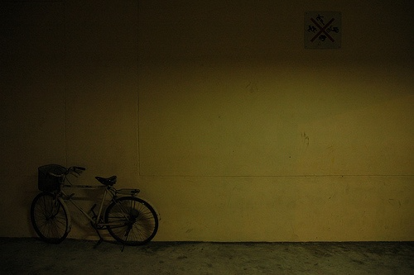  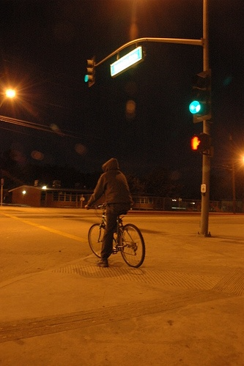  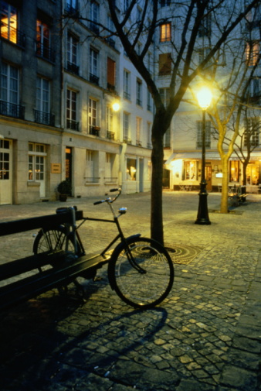 | 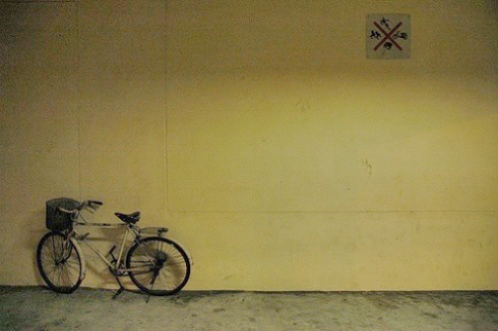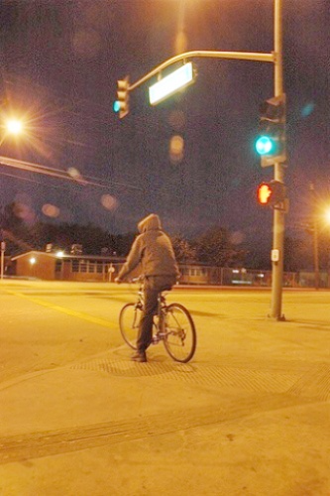  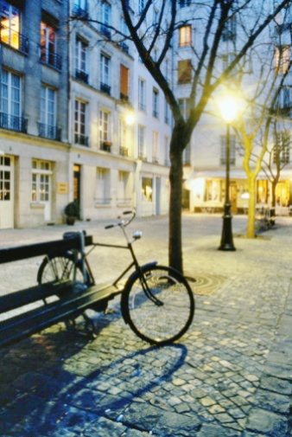 | 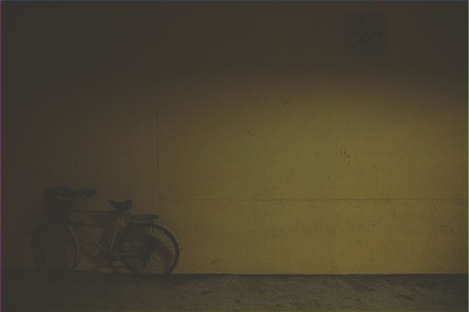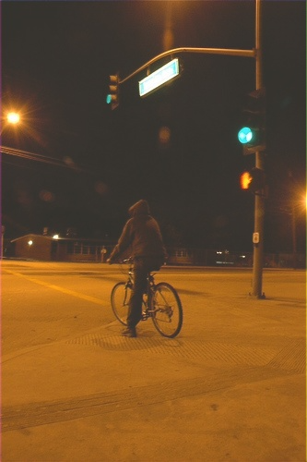  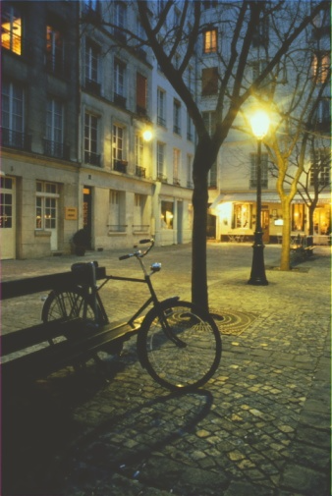 | 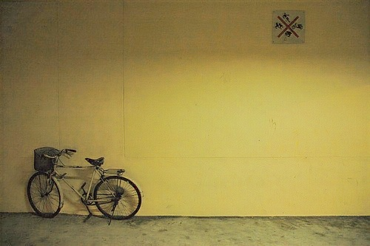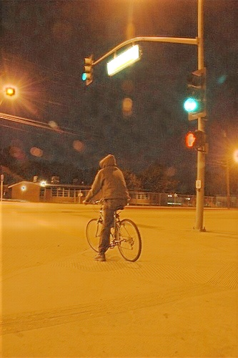  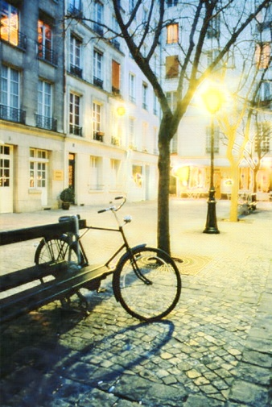

Low-light Image Inversion= Y_{GT}= Y_{P}* W

Evaluate the enhanced images using NR-IQA
https://github.com/EadCat/NIQA
https://github.com/topics/blind-image-quality-assessment

ExDark Raw | Zero-DCE++ | SCI | Retinex former

SNR - Aware | LIME | PairLIE | KinD++
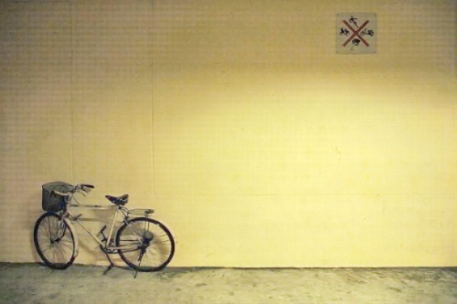 | 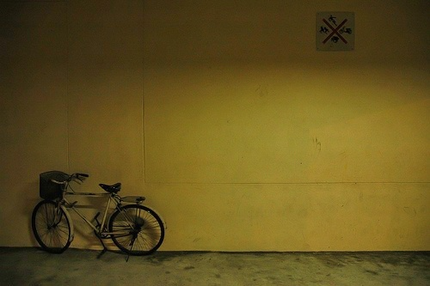 | 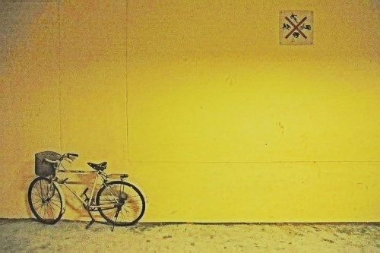 | 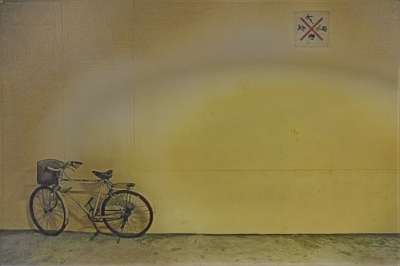

ExDark Raw  (YOLOv8n) | Zero-DCE++ | SCI | Retinex former
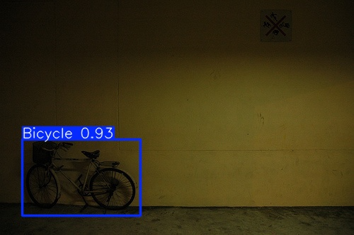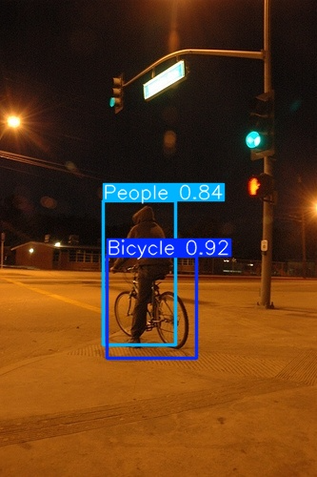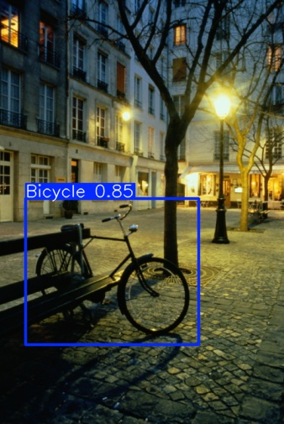 | 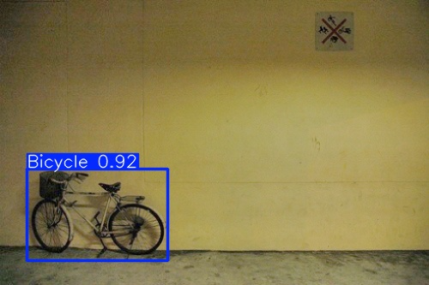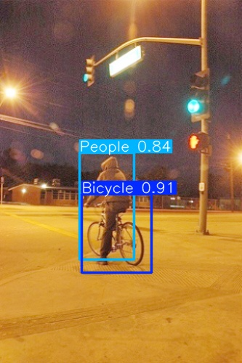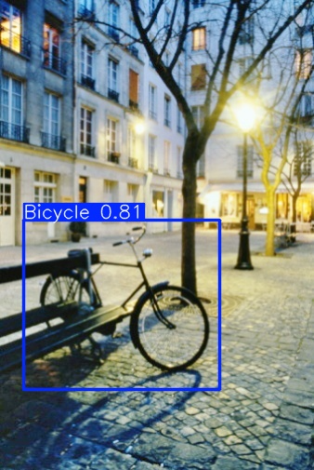 | 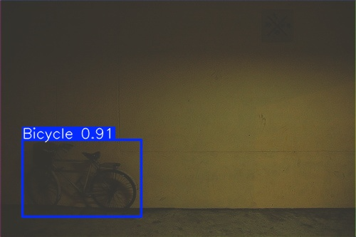  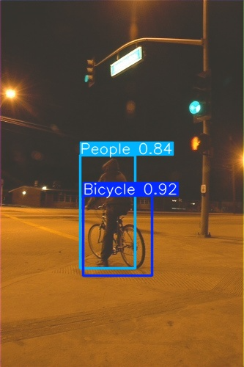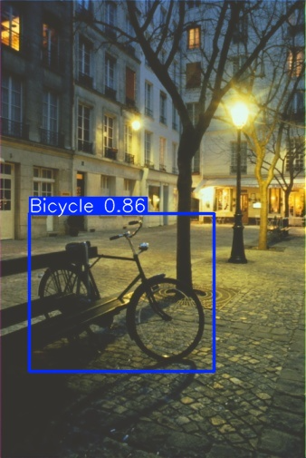 | 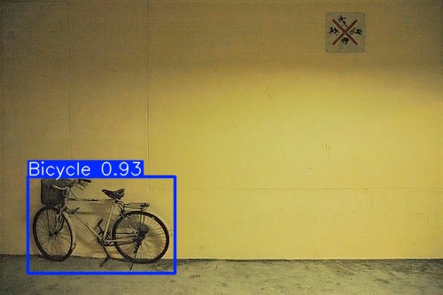  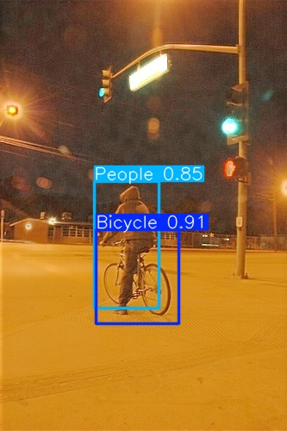  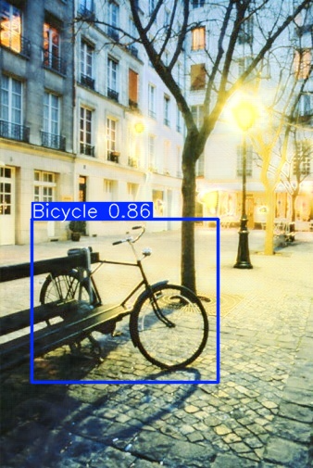

Dataset Planning
Dataset | Use or not? | Correct use
ExDark | Yes, main | Main low-light object detection benchmark. Officially 7,363 images, 10 low-light conditions, 12 classes, image-level and local bounding-box annotations. (GitHub)
LoL | Yes, but not for detection | Use only for enhancement PSNR/SSIM/LPIPS because it has low/normal-light pairs, not detection boxes. LOL has 500 pairs, 485 train and 15 test. (Kaggle)
LoL-v2 real | Yes, but not for detection | Use for enhancement metrics only; 689 training and 100 testing images. (Hugging Face)
LLVIP-visible | Yes, priority 2 | Low-light pedestrian detection; official page says 30,976 images / 15,488 aligned visible-infrared pairs, pedestrians labeled. Use visible channel first. (BUPT AI CZ)
Dark Face | Yes, priority 3 | Specialized low-light face detection; official page says 6,000 labeled low-light images, 9,000 unlabeled images, and held-out test images. (Flyywh)
BDD100K-night | Yes, priority 4 | Real driving detection/night subset. BDD100K is a large driving dataset with 100K videos and diverse environmental/weather conditions. (arXiv)
ACDC-night | Optional | Mainly adverse-condition driving with panoptic/semantic labels; use only if we clearly separate object detection/segmentation. ACDC has 4,006 adverse-condition images across fog, nighttime, rain, snow, with normal-condition correspondences. (ACDC Dataset)
NightOwls | Later | Very large nighttime pedestrian benchmark; 279k frames in 40 sequences. Use after ExDark + LLVIP + Dark Face. (Oxford University Research Archive)
FLIR / KAIST | Not in main paper initially | These are thermal/multispectral datasets, not pure visible low-light enhancement. KAIST has 95k color-thermal pairs. Use only in future multimodal extension. (Soonmin Hwang)

Mark down complete if task are done complete-
Stage 1 — Complete ExDark fully
- Raw ExDark.
- Zero-DCE++ ExDark.
- SCI ExDark.
- Retinexformer ExDark.
- SNR-Aware ExDark.
- PairLIE ExDark.
- Diff-Retinex ExDark.
- LIME ExDark.
- KinD++ / RetinexNet ExDark.
Detectors:
- YOLOv8n / YOLOv8s.
- YOLOv10n / YOLOv10s.
- RT-DETR.
- Faster R-CNN.
- Deformable DETR.
- Optional: DINO / Co-DETR if GPU time allows.
Stage 2 — Add only 2–3 generalization datasets
Do not immediately add all 9 datasets. Add:
- LLVIP-visible.
- Dark Face.
- BDD100K-night.
NightOwls can be a later extension. ACDC/FLIR/KAIST should not be in the starting unless we create a clearly separate multimodal/adverse-weather section.
Stage 3- Add the missing protocol that explains our current drop

Protocol | Train | Test | Why needed
P1 | Raw | Raw | Normal baseline
P2 | Raw | Enhanced | Tests whether enhancement at inference causes domain shift
P3 | Enhanced | Enhanced | Tests whether detector can adapt to enhanced domain
P4 | Raw + Enhanced mixed | Raw + Enhanced | Tests robust training
P5 | Detection-aware enhancement + detector | Enhanced/adaptive | our proposed solution
Stage 4 - Add sample images and GT properly

Figure 2: Dataset samples with ground truth.
Rows:
- ExDark: raw low-light image + GT boxes.
- LLVIP-visible: visible low-light image + pedestrian GT.
- Dark Face: low-light face image + face GT.
- BDD100K-night: night driving image + object GT.
- LoL/LoL-v2: low-light input + normal-light GT, but clearly label as enhancement-only.
For each detection dataset, show:
Raw image | GT boxes | enhanced image | detector output
Generate the figures from our own downloaded dataset files only.
Stage 5- Little change in the equation
Instead of:
Y_GT = Y_P × W
Use:
Ienh=clip(Iraw⊙Wθ(Iraw))I_{enh} = \mathrm{clip}(I_{raw} \odot W_\theta(I_{raw}))Ienh​=clip(Iraw​⊙Wθ​(Iraw​))
Where:
- IrawI_{raw}Iraw​ is the low-light image.
- WθW_\thetaWθ​ is a learnable illumination/adaptation map.
- IenhI_{enh}Ienh​ is the detector-preserving enhanced image.
- Bounding boxes remain valid because the transformation is pixel-wise and does not change geometry.
Then train it with:
L=Ldet+λ1Lfeat+λ2Lobj+λ3Ltv+λ4Lid\mathcal{L} = \mathcal{L}_{det} + \lambda_1 \mathcal{L}_{feat} + \lambda_2 \mathcal{L}_{obj} + \lambda_3 \mathcal{L}_{tv} + \lambda_4 \mathcal{L}_{id}L=Ldet​+λ1​Lfeat​+λ2​Lobj​+λ3​Ltv​+λ4​Lid​
Meaning:
Loss | Purpose
Detection loss | Improves mAP, classification, localization
Feature consistency loss | Prevents detector feature distortion
Object-region loss | Enhances object boxes more carefully than background
TV smoothness loss | Prevents noisy illumination map
Identity/background loss | Avoids over-enhancement where image is already visible

Stage 6 - Experimental tables we should prepare

Main table 1: ExDark detector benchmark
Dataset | Input | Detector | mAP@0.5 | mAP@0.5:0.95 | Precision | Recall | F1 | FPS

Table 2: Enhancer × detector matrix
Enhancer | YOLOv8 | YOLOv10 | RT-DETR | Faster R-CNN | Deformable DETR
Raw
Zero-DCE++
SCI
Retinexformer
SNR-Aware
PairLIE
Diff-Retinex
LIME
Ours

Table 3: Protocol ablation
Protocol | Train image type | Test image type | mAP@0.5 | Conclusion
P1 | Raw | Raw |  | Baseline
P2 | Raw | Enhanced |  | Tests inference shift
P3 | Enhanced | Enhanced |  | Tests adaptation
P4 | Mixed | Mixed |  | Tests robustness
P5 | Ours | Ours |  | Tests proposed method

Table 4: Per-class ΔAP
Class | Raw AP | Zero-DCE++ ΔAP | SCI ΔAP | Retinexformer ΔAP | Ours ΔAP

Table 5: Correlation analysis
Metric | Pearson with ΔmAP | Spearman with ΔmAP | Interpretation
PSNR |  |  | Paired datasets only
SSIM |  |  | Paired datasets only
LPIPS |  |  | Paired datasets only
NIQE |  |  | No-reference
BRISQUE |  |  | No-reference
Entropy |  |  | Information richness
Exposure error |  |  | Brightness quality
Enhancement strength |  |  | Over-enhancement risk
Finish ExDark completely.
Add missing protocol: raw-train/raw-test, raw-train/enhanced-test, enhanced-train/enhanced-test, mixed-train.
Add per-class AP, object-size AP, illumination-condition AP.
Add correlation analysis and statistical significance.
Add sample image + GT figure from every dataset.
Add LLVIP-visible, Dark Face, and BDD100K-night only after ExDark is complete.
Propose our own detection-preserving enhancement module.
Compare our method against Zero-DCE++, SCI, Retinexformer, SNR-Aware, PairLIE, Diff-Retinex, LIME, KinD++.

